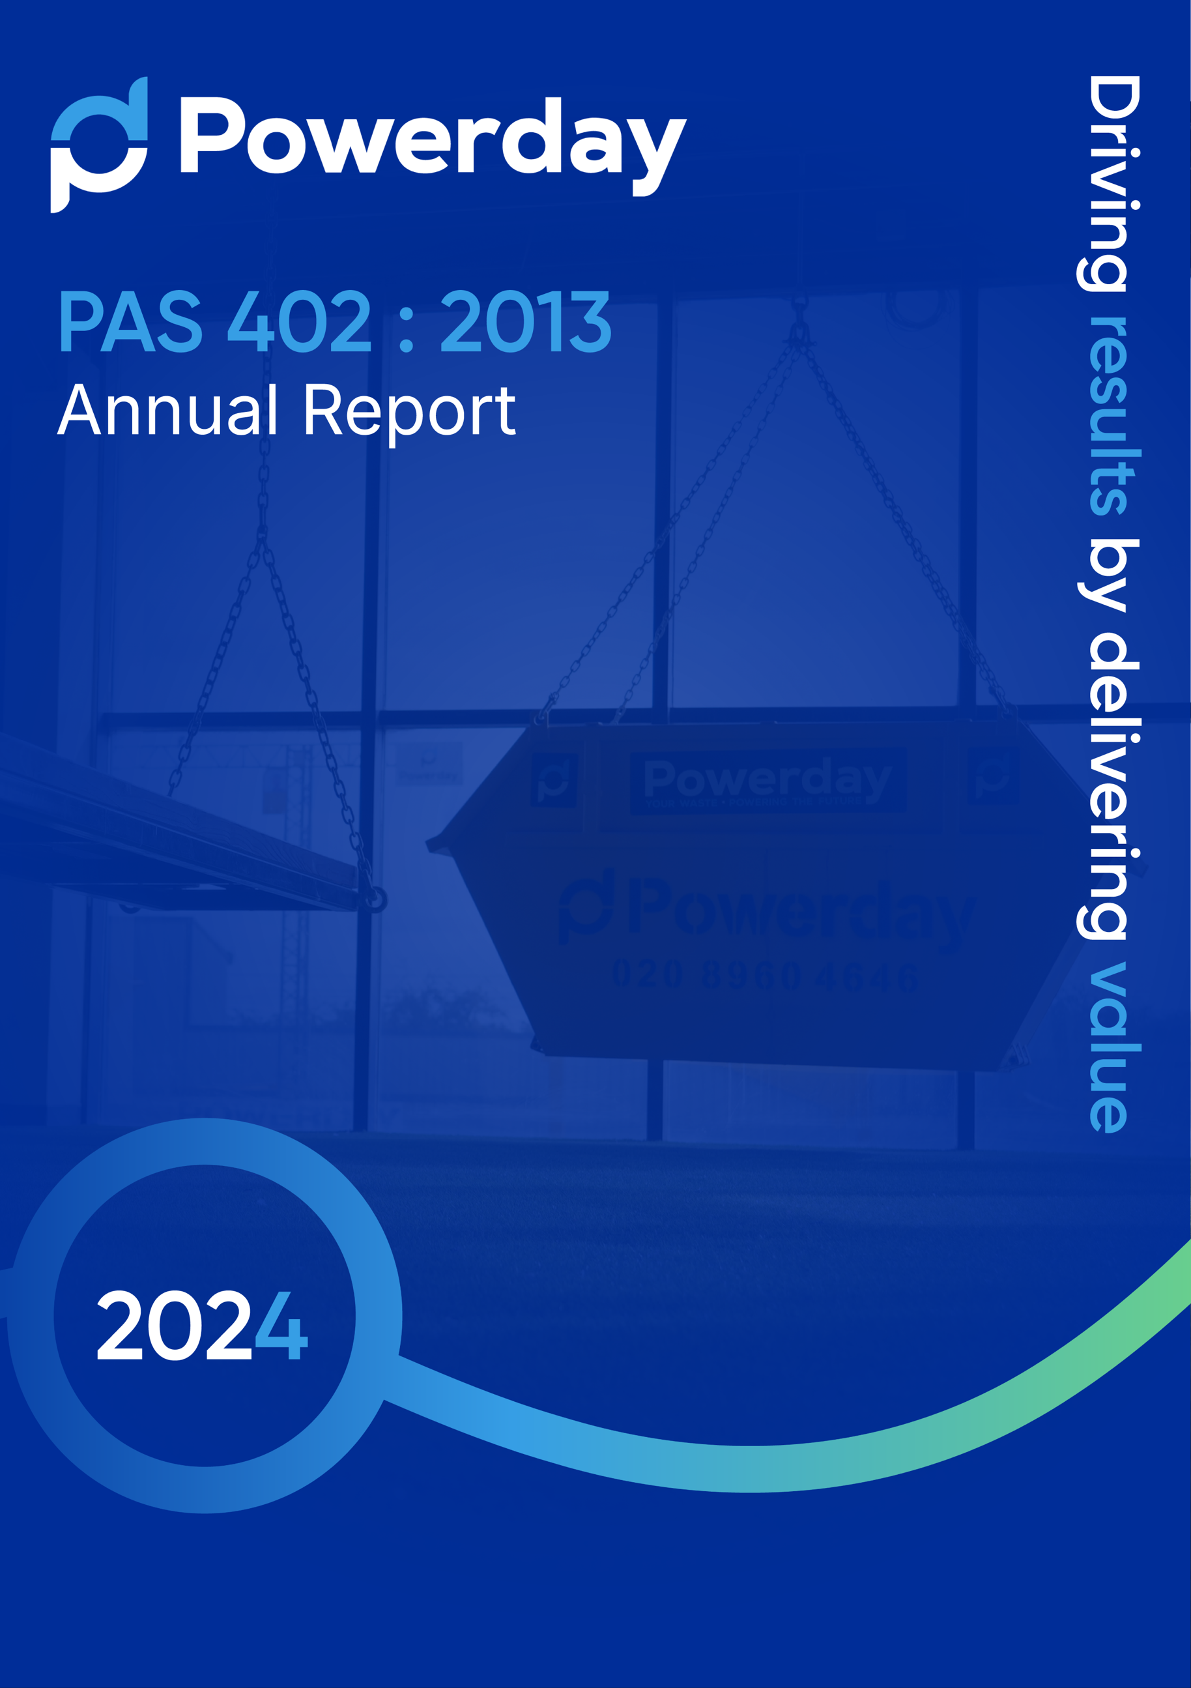

Contents

Introduction
Section 4. Scope of Operation
Section 5. Client Relationship
Section 6. Impacts and Risks
Section 7. Operational Management
Section 8. Competence
Section 9. Legal and other requirements
Section 10. Corrective, preventive and improvement actions
Section 11. Performance review
Appendices

Introduction
Powerday has a long and successful track record in waste management and associated services. The company has been trading since 1977, its original business being very much within the construction sector. During the 1980’s and ‘90’s, the company evolved into an integrated waste management business and has over the last 10 years invested significantly in the development of 3 modern state-of-the- art recycling plants, facilities and equipment. Our business has eight operational locations which include two Materials Recovery Facilities, in Willesden Junction Northwest London and Enfield, North London. We also have six waste transfer stations in Bermondsey, Canning Town, Croydon, Brixton, Wimbledon and Heathrow and Croydon. All site Environmental Permits can be found in appendix 1-6.
The Powerday mission is to excel in resource recovery and recycling, and to maximise diversion of waste material away from traditional ever more expensive landfill. We achieve this through working closely with local authorities and business to determine needs and developing our systems with our plant and equipment partners to satisfy this changing requirement. Our success in this field is further enhanced with a proven and experienced back of house team. This includes expertise in engineering, construction, quality standards, health and safety, planning and legislative compliance.
With an ethos of ‘giving back’ we use our sustained growth to support local communities. Our work in the community is as important to our company as our waste management services. In the past 12 months, we have generated £13.8m in social value.
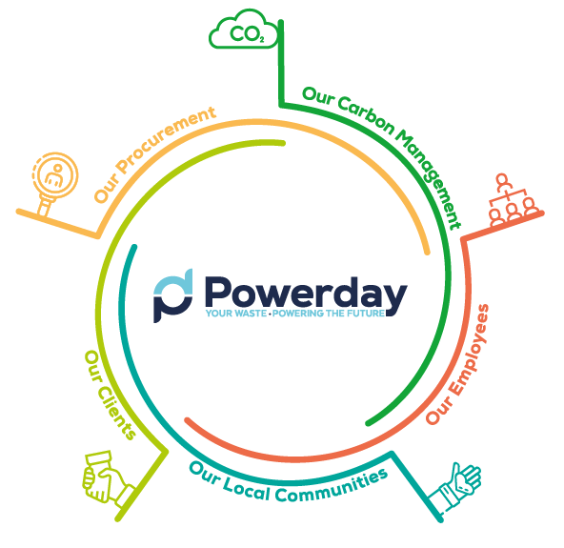
We recently launched our fifth Sustainability and Wellness manifesto, which demonstrates our social value and sustainability efforts and aims. As well as these targets, our Manifesto plots our roadmap to net zero in line with our recently announced net zero target for scope 1 and 2 and shares this and our other successes for 2023. Sustainability is a multi-faceted term that is adapted dependent on the business goals. At Powerday, we define sustainability as ‘shaping an
environment which promises business longevity whilst reducing the climate impact of our operations and investing in our local communities’. We have split our sustainability goals into 5
sustainability pillars: Our Employees, Our Local
Communities, Our Clients, Our
Carbon Management and Our Procurement.
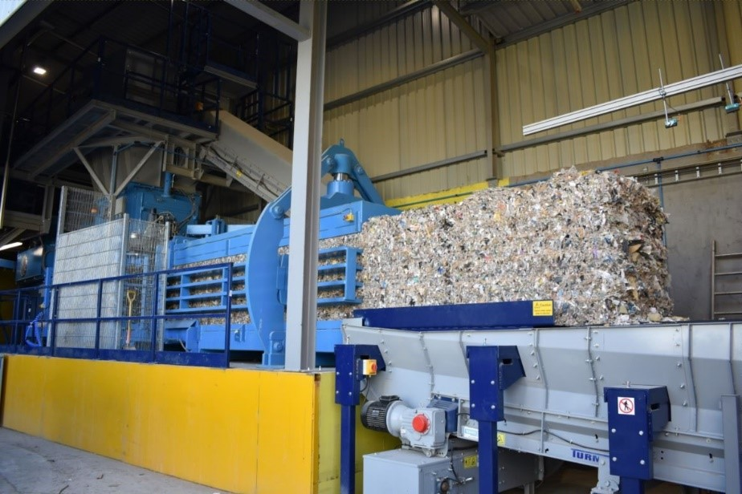
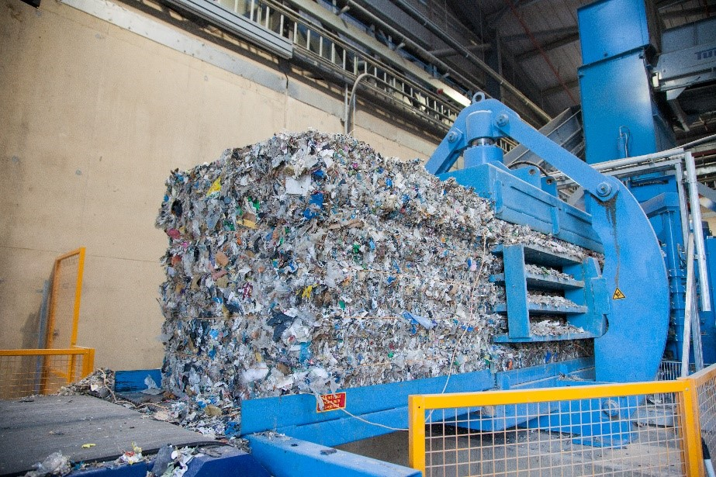
In 2006 the Old Oak Sidings Materials Recycling Facility was opened in Northwest London. This facility, the largest of its type in the UK, is licensed to receive and process up to 1.6m tonnes of waste material each year, operating 24 hours a day. It is a purpose-built facility occupying a nine-acre site, employing the latest technology designed to maximise the recycling output and to produce a Refuse Derived Fuel (RDF) to varying specifications.

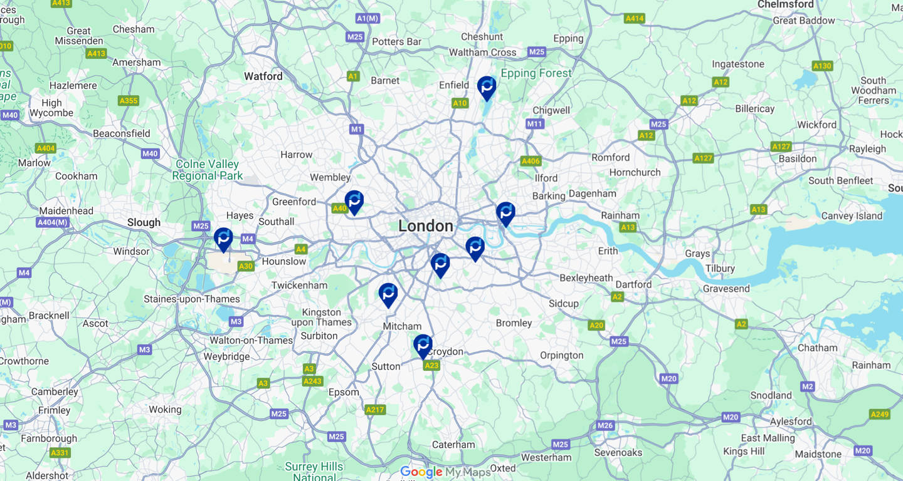
Sites are identified and strategically positioned to enable Powerday to provide a direct service to a larger community, reducing the need to use sub-contractors. All sites are fully compliant with current legislative and compliance legislation. Outlets for processed materials are closely monitored and audited to ensure the levels of compliance are as required.
This document has been reviewed and approved by:
Jim Craig
Managing Director (Joint)
Signature ……………………………………………… Date ……………………………………
Liam Kearney
Managing Director (Joint)
Signature ……………………………………………… Date ……………………………………

Section 4. Scope of Operations
Powerday’s roots lie in the supply of labour to the construction industry. As the company evolved the portfolio was expanded to include skip services and some low-level treatment of waste. The development of the main facility at Old Oak Sidings in London NW10 and the second MRF site in Enfield has meant that Powerday can supply a full waste management solution which includes waste collection, and the off - site processing of mixed waste materials.
Powerday can provide various size skips and Roll on Roll off (RoRo) containers to sites within the Greater London area and enhances this with a third-party service supply agreement through our National Solutions Team. Our main processing facility operates 24 hours a day, 7 days a week and is licensed to accept 1.6 million tonnes of waste per annum and operates under Environmental Permit No. EPR/PP3093EE.
Constant development of the Old Oak Sidings facility enhances the specification of processed waste to the end disposal points. Residual waste is produced to varying specifications for use by Energy from Waste (EfW) plants in the UK and Europe.
Powerday’s waste transfer stations are strategically located around London to act as a hub for all parts of London, to enable us to provide local, cost-effective waste collection services to our construction clients in all areas of London, whilst reducing waste miles an minimising transport emissions.
Waste is bulked at our waste transfer stations and then transported to either Willesden or Enfield for processing.
Full details of all Powerday MRF facilities are shown below along with our supporting waste transfer sites.

Site Name | Contact Details | Site Address | Site License Number  Exemptions  Planning Permission
Brixton  (full permit in appendix 1) | George Daniels  020 8960 4646 | Powerday Brixton  4-16 and -13 Belinda Road, Brixton,  SW9 7DT | EPR/JB3637RK No Exemptions 90/1326/32268
Canning Town  (full permit in appendix 2) | Michael White  020 8960 4646 | Powerday Canning Town  Stephenson Street, Canning Town,  E16 4 | KB3507UG  No Exemptions  T/APP/G5750/A/98/1011619/P5
Croydon | Chris Batterbee  020 8960 4646 | 122 – 124 Beddington Lane,  Croydon,  CR0 4YZ | EPR/CB3202LJ  Planning application in progress.
Heathrow  (full permit in appendix 3) | John McKenna  020 8960 4646 | Powerday Heathrow Holloway Lane,  Sipson West Drayton,  UB7 0AE | EPR/JB3400HB/T001  No Exemptions  43155/APP/2019/2616
Enfield  (full permit in appendix 4) | Georgie Swaby  020 8960 4646 | Powerday Enfield  Jeffrey’s Road,  Brimsdown, Enfield  EN3 7TL | EPR/AP3391NF  No Exemptions  P13-02160PLA
Willesden  (full permit in appendix 5) | John Davitt  020 8960 4646 | Powerday, Old Oak Sidings, Crossan  House, Off Scrubs Lane, Willesden,  NW106RJ | EPR/PP3093EE  Aggregate Crushing Permit  2006/00037/MOBCRU/V2  S2 Exemption WEX437355  2003/03409/FUL
Wimbledon  (full permit in appendix 6) | Joe O’Rourke  020 8960 4646 | Powerday Wimbledon, 36 Weir Road, Wimbledon, SW19 8UG | EPR/HB3802GH  No Exemptions  13/P2585
Bermondsey  (full permit in appendix 7) | Tim Long  020 8960 4646 | 3 Mercury Way,  Bermondsey,  SE14 5RR | XP3990EF Currently operated by Economic Skips. To be transferred to Powerday Permit.

Powerday offers waste collection services to customers mainly within the M25 boundary. This service is carried out by Powerday’s own staff and vehicles. All drivers are fully qualified and experienced in skip and RoRo delivery, collection and exchange. This experience is further enhanced with ADR Training which allows Powerday to collect and transport dangerous goods. Powerday’s Environmental Permit also allows for the handling of construction and demolition wastes containing dangerous substances. Powerday can collect and segregate for onward disposal, CoSHH and asbestos generated on a construction site.
The updated PAS 402 will cover all eight of Powerday’s locations operating in 2024.

National Solutions
Customers that require collections outside of the direct service area would be dealt with via our National Solutions Team. We provide National Solutions throughout the UK, extending our total waste management services beyond our traditional London and Southeast operating areas. Powerday national solutions provides a full range of containment options including skips, RoRos and wheeled bins. This team organises third party companies local to the collection site. Under strict service level agreements these companies provide the service on behalf of Powerday. The Service Level Agreement (SLA) will include, reporting protocols, Key Performance Indicators as agreed at contract commencement, relevant training and legislative, environmental and Duty of Care compliance.

Client Testimonial
“Powerday have been as adaptable as possible to our needs, they have provided effective waste management services on a highly congested site and in a sensitive location. Powerday’s digital tickets and online document portal has also helped us streamline our project reporting and demonstrate compliance with our legislative demands. Their off-site recycling facilities also achieved our target of sending zero waste to landfill.” Tom King, Sustainability Manager at Sir Robert McAlpine.
“Mace is pleased to collaborate with Powerday to provide sustainable waste management solutions at Heathrow Airport, as part of our ongoing commitments under the Q6 framework.” Richard Miles, Commercial Director at Mace Ltd.
“Powerday has been crucial in supporting our ‘Better with Bellway Strategy’ by helping us achieve the lowest waste per unit across the Bellway Group. Their support in waste segregation and efficient setup of waste stations has been essential. We are grateful for Powerday’s continued support.” Colin Marshall, Commercial Director at Bellway North London.

Section 5. Client Relationship
All customers are able to contact us with queries about our services via telephone on 020 8960 4646 or the Powerday website. In every case, customer enquiries are managed by our dedicated trained and experienced support staff based at our main facility at Old Oak Sidings. Following the award of any contract, and prior to commencement, Powerday will organise site visits and contract meetings to determine the best operational method considering both the contract terms and individual site requirements. These visits and meetings will be the basis of the relationship moving forward and will generate a Site Information Pack (SIP). The SIP is a site-based document that will include information about services, legislative and environmental compliance and documents required to comply with audit process. Regular site visits by Powerday personnel will ensure that this information and the activities on site are compliant. Each visit is recorded using a Site Visit Report which is used for reference at Contract Management Meetings.
During 2023 Powerday has further developed its online reporting tool that gives customers access to their waste data. The Portal provides, through personalised access codes, live data including waste composition, diversion statistics, waste transfer notes and invoice details. Example reports are shown in the waste report example document. Below are some examples of our new reporting system which we are currently trialling and will launch in 2025.
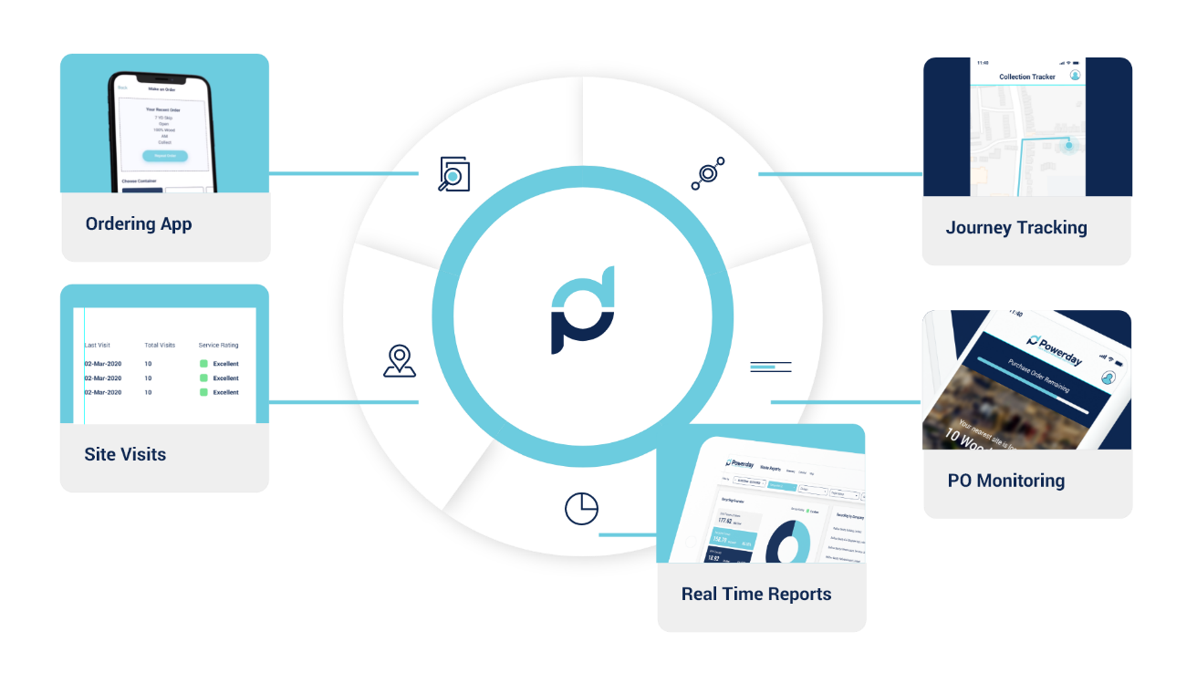
Accurate tonnage data will be recorded using weighbridge software identifying inputs for each customer, whether delivered directly to our premises or collected by Powerday prior to treatment.
This monthly total tonnage data will be the baseline to which recycling and recovery rates are applied. Once a vehicle has entered via the site weighbridge it is directed to the appropriate tipping area dependent on type of waste carried. Segregated wastes will be tipped in designated waste areas, i.e. wood, plastic, cardboard etc. Mixed waste containers are tipped onto the processing hall floor and visually assessed by a qualified operative to determine the waste composition. This information is input onto the waste system via PDA and this data forms the basis for monthly reporting. The level of reporting provides sufficient data to comply with current BREEAM requirements.
Powerday will identify the end markets for the recycled elements and submit these material destinations monthly to our clients. A weighbridge ticket for each transaction is generated electronically and is submitted with monthly invoices or can be viewed and downloaded via the Powerday website. Powerday will provide a copy of the relevant licenses for any of the destinations at the commencement of the contract.
Where material is either collected by Powerday or directly delivered to the Powerday facility, which on inspection is found to be not as described on the waste transfer note, Powerday will record and photograph the load(s) in question and inform the customer to agree what action might need to be taken. This could include a reclassification of the waste or the waste being rejected. A schematic of the process is shown at Appendix 8 – Material Waste Flowchart.
Meeting and exceeding the expectations of our customers is at the heart of everything we do. Whilst considering this, we have achieved full accreditation under ISO9001 Quality Management System so that we can constantly improve in this area. Powerday has dedicated Business Development Managers who regularly visit and liaise with customers to assess the level of service that we provide and to gauge customer satisfaction levels. Additionally, we periodically undertake customer surveys so that we can use this feedback to set future improvement targets.
If we receive a complaint from a customer, they are dealt with through our formal complaint’s procedure. We strive to provide an initial response to all received complaints within one working day of receipt. The relevant members of staff will then undertake an investigation to determine the root cause of the problem and any corrective and preventive actions that are required. The results of this investigation will be communicated to the person(s) making the complaint at the earliest opportunity. All complaints are documented on our Complaints Register which is analysed by management monthly to identify any possible trends so that appropriate remedial actions can be taken.

Section 6. Impacts and Risks
Powerday has achieved ISO 9001, ISO 14001, and ISO 45001 accreditation. Copies of certificates attached at Appendix 9, 10 and 11.
The system utilises a risk-based methodology, enabling us to recognise those activities that are critical to the success of the business. To determine these critical points, we undertake a period of consultation with those directly involved in the operations with the purpose of identifying any external pressures associated with the activities e.g. legislation, customer specifications etc. The same methodologies are applied to all facets of the business ranging from; the establishment and delivery of customer requirements; analysis and determination of employee training needs; and the identification and control of significant health, safety and environmental risks.
Where critical activities are identified, we will review the processes and procedures that we currently have in place to meet, and preferably exceed, them. Where current measures are deemed insufficient, we will identify additional controls such as the introduction of documented procedures, risk assessments and work instructions, further training programmes and infrastructure improvements. To control work related impacts and risks, Powerday has developed and maintains through regular assessment and reviews an extensive Risk Assessment register. (example attached at Appendix 12).
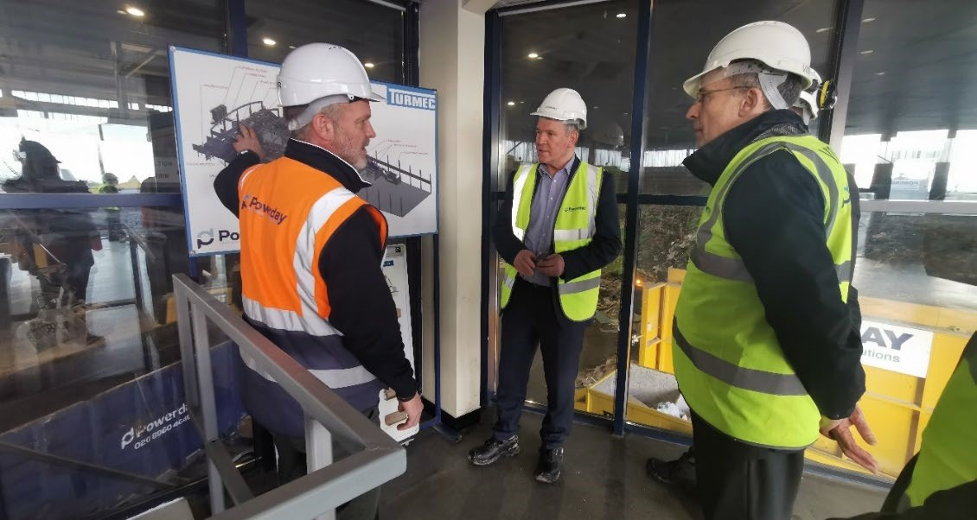
We regularly review and when necessary, update our Business Continuity / Emergency Response Plan (copy of current document attached at Appendix 13) which addresses the company’s exposure to internal and external threats. This establishes both prevention and mitigation measures to provide effective prevention and recovery for the company, whilst maintaining competitive advantage and value system integrity.
After the initial stage of planning and understanding the level of work and ensuring sufficient resource is allocated to enable the successful delivery of the work, we also establish review meetings at different stages of the activity to enable us to evaluate whether our operations and systems are working as agreed.
Key Performance Indicators are allocated to critical activities, and continuous improvement programmes are implemented to further tighten our control of these key areas. Monitoring data is collected e.g. customer review meetings, accident reports, recycling rates etc. and this is reviewed and analysed for progress at defined intervals by those responsible for each area. Progress is reported to senior management during the quarterly management meetings. Where issues are reported, appropriate corrective and preventive actions will be attributed and monitored closely to ascertain whether they have been successful in eliminating the problem.
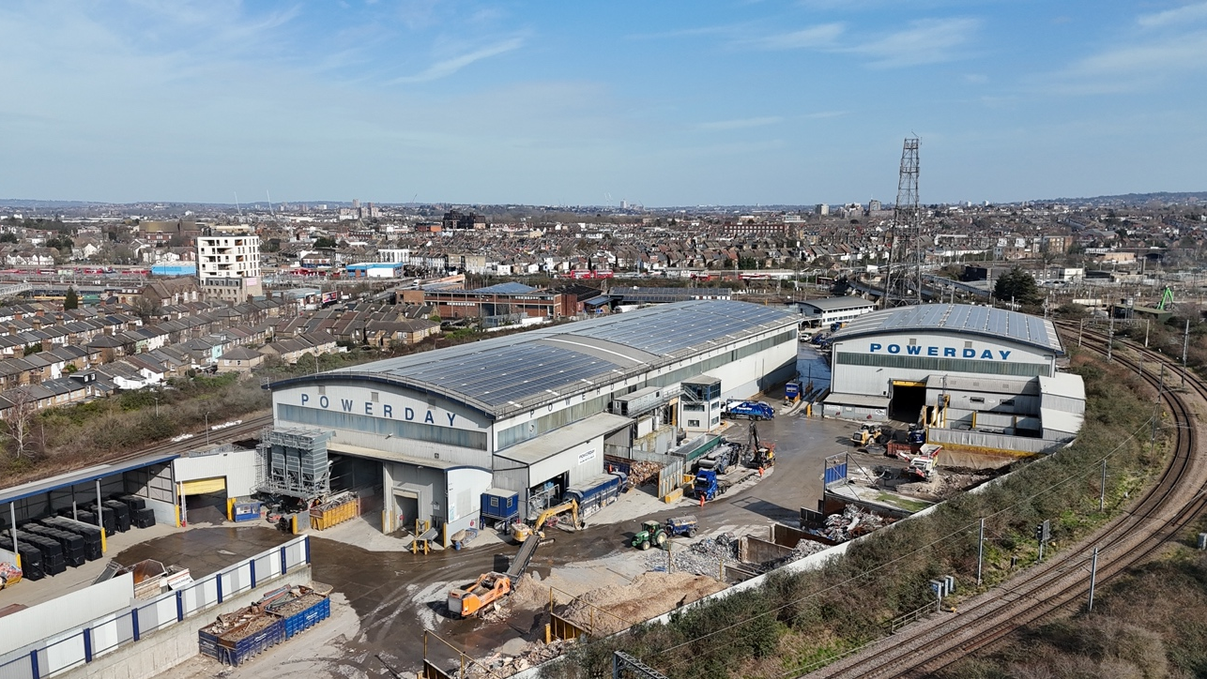

Section 7. Operational Management
Powerday has a clear definition of roles and responsibilities to conduct business. Each function is assigned to a Company Director who, reporting to the Managing Director and ultimately the
Chairman, have total responsibility for their activities. Organisation and function chart below.

Overview
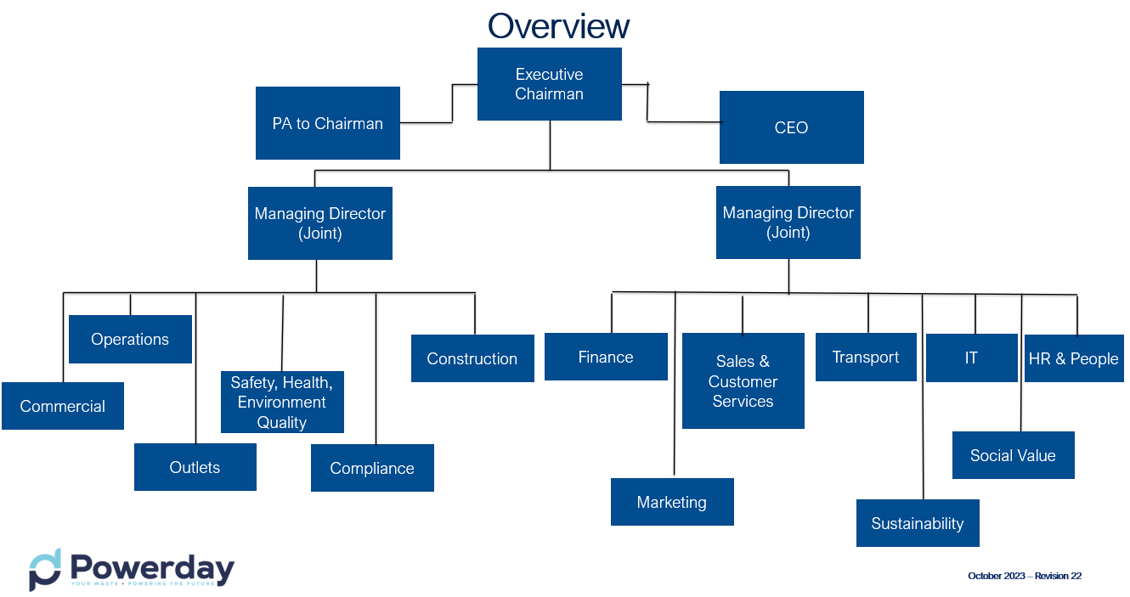
Our management systems include documented procedures that control our business. All staff have controlled access to this system.
We have developed documented control procedures to cover all stages of our business activities. For example, customer needs are determined in accordance with our customer requirements process. This process covers the period from the initial enquiry, establishing customer requirements followed by delivery of the service and a final service review to determine service successes and improvements. This ensures a cradle to grave process.
Nothing is more important to us than ensuring the safety of our staff, our surrounding environment and any other persons affected by our operations. We have conducted risk assessments on all activities and where appropriate, we have developed documented safe systems of work and operational procedures to control the risks. We currently manage more than 100 activities in this way, including the acceptance, sorting, storage and disposal of waste, traffic management and site rules for visitors, dealing with spillages and emergency response.
If it is anticipated that there is more than one transfer of waste, as such we ensure that appropriate duty of care measures is applied. This entails records of incoming wastes with its appropriate EWC code(s), the weight of that waste, together with the next or end destination of waste. We have suitable and sufficient waste containment bays and containers that are used within the site permit boundary. A duty of care compliance matrix is included in Appendix 14.
All wastes are held on site in compliance with our permit conditions. The license allows for the acceptance and processing of CoSHH waste. During this period, we amended our environmental permit and expanded the number of hazardous waste EWC codes that we can accept. All hazardous wastes is collected using our ADR qualified drivers and vehicles and transported to one of our permitted authorised disposal points. Constant daily monitoring of operations and site activities by supervisory staff allows management to have a clear understanding of how waste is received, processed, stored and dispatched to onward processing destinations. Through this constant monitoring process and documented procedures, Powerday can ensure compliance with its permitted capacity and storage conditions.
In addition to the documented procedures, we undertake a range of audits and inspections in accordance with the various standards to which we operate to ensure that procedures are adhered to. Daily and weekly inspections of the site are undertaken to determine whether we are operating in accordance with our Permits/exemptions and vehicle and plant inspections are completed prior to work commencement every working day.
Any waste our organisation generates, where possible are recycled and stored, handled and disposed of in line with duty of care requirements
We undertake forward planning to ensure that allocation of resources is effective across the business. Waste operations are planned daily and based on customer demand and market considerations. All business planning is undertaken within the scope of our Business Continuity Plan which addresses resource in unexpected and emergency situations.
Our waste operations are monitored throughout each day, enabling us to have a clear understanding of the waste being received by the Company and the waste that is leaving site. This provides us with the total amount of waste held on site, confirming compliance with the capacity conditions.

Section 8. Competence
Training needs of all staff are established in a variety of ways which includes a system of formal appraisals, through analysis of risk assessments and via constant monitoring of work activities by use of the internal audit process and corrective action procedure.
All employees receive induction training, which comprises a series of videos, a comprehensive induction covering both inside the building and site activities. Each employee receives a copy of our health and safety policy. All our employees also receive Safety, Health and Environmental Awareness training.
To further complement our induction training, we operate a formal appraisal system. Appraisals are conducted by our Management Team who will meet face to face with each employee and analyse the performance and training requirements for everyone. The employee is invited to review their own performance and to suggest any training requirements that they feel they have, that can help improve their own performance.
Because of the appraisal, an individual training plan is determined for the employee and where appropriate, additional training needs identified are added to the training plans of all employees that perform similar tasks. The training plans include training provided both in-house and where necessary, by external providers
All training requirements are recorded on a training matrix. The training matrix also identifies and flags updates of when certain training needs to be refreshed e.g. First Aid qualifications expire after 3 years etc. An example Training Matrix is attached at Appendix 15.
A program of toolbox talks is carried out on a weekly basis. Although there is a schedule in place, it is flexible and can be changed to pick up topics of immediate importance e.g. a new task is about to commence, a near miss or accident has occurred etc. To ensure that employees have understood the content of the toolbox talk, the person delivering the talk will ask them a series of questions relating to the topic. If acceptable answers are provided, then the employee is asked to sign the document to show that they have received and understood the talk and this information is recorded along with the date the talk was delivered Records and certificates of all employees training are kept on the individual’s file. Our external consultants undertake a programme of audits annually which includes a check on competency levels and effectiveness of training undertaken.
We have also achieved Fleet Operators Recognition Scheme (FORS) Gold Accreditation for the eleventh year running, details of which can be found on the documents page on our website.
We also understand that we have a responsibility to ensure that those working on our behalf are competent to undertake their roles. As part of our commitment to maintaining our accreditation to ISO 9001, ISO14001 and ISO 45001, it is essential that we verify that our subcontractors are meeting legislative compliance as a minimum but also conforming to our own high standards.
Before we allow any sub-contractor to undertake work on our behalf they must demonstrate to us that they meet a set of strict criteria.
We prefer to use subcontractors that have independently verified management systems in place, but we will not exclude companies from working for and/or with us providing they can demonstrate sound management practice.
We understand that each sub-contractor is different and that the services they provide can vary enormously. Therefore, as well as the generic questions we will also request service specific documentation from then. For instance, when dealing with other waste management outlets we would request the following information:
Insurance(s)
- Site License (Exemption, WML, Permit)
- Operator’s License
- Waste Carrier/Brokers/Dealer License (appendix 16)
- Health & Safety, Environment, Quality Policies
- Working towards or have achieved PAS 402 accreditation
- Job specific Risk Assessments, Method Statements and/or Safe Systems of Work
- Driver Licenses (HGV)
- Other Training certificates e.g. SHEA, ADR
Once the verification is carried out and appropriate criteria are met, the company is then placed on our Approved Supplier / Subcontractor list and all evidence is filed for retention. The service provided by the sub-contractor is assessed periodically and where necessary further information e.g. new legislative requirements, competencies etc. is requested to ensure that they continue to meet minimum requirements.
Prior to commencement of work on our sites, we ensure that sub-contractors undergo a stringent site induction. This includes making them aware of our health, safety, environment and quality policies as well as relevant risk assessments, controls and emergency procedures.

Section 9. Legal and other requirements
We achieve legal compliance through advice from internal expertise, external specialist consultants and regular liaison with regulators. Powerday directly employs an in-house SHEQ Manager and SHEQ Advisor who undertake regular site inspections and audits to ensure that we are compliant with all applicable legislation.
Through our accreditations of ISO 9001, ISO 14001 and ISO 45001, we are audited annually by a UKAS accreditation body. After undertaking each audit, they produce an audit report summarising what was looked at, evidence gathered, any non-conformances and opportunities for improvement. These reports are reviewed by Senior Management for approval. The findings of the internal audit programme are discussed at both the quarterly management system meetings as well as at the full management review which takes place annually.
In addition to schedule audits, we also undertake daily and weekly inspections of all facilities, the Site Manager responsible for the Environmental Permit will check current operations against various conditions of the permits such as storage conditions, retention times, drainage etc. Any problems or issues identified are recorded and returned to the SHEQ and Compliance Managers who will instigate appropriate corrective and/or preventive actions.

Section 10. Corrective, preventive and improvement actions

Our business performance including safety, health, environmental and quality issues is continuously monitored and reviewed but as with all businesses occasionally problems arise. At Powerday we see this as an opportunity rather than a negative as only by identifying these issues can we do something about them. As part of our commitment to the various standards to which we are certified, we have developed a non-conformance, corrective and preventive action system to address any problems that may arise.
Wherever actual or potential problems are identified they are recorded and documented through our non-conformance, corrective and preventive action procedure. A corrective action can be raised by any member of staff that identifies a non-conformance, a potential non-conformance, near miss or opportunity for improvement. All employees are encouraged to use this mechanism as it helps to provide management with an overview of what is happening on site and with our customers.
Non-conformities are discussed at management reviews to identify any potential trends that may be developing, i.e. the same customer bringing in nonconforming loads on several occasions. Further investigation with our Business Development Team, and where necessary the customer, allows us to identify the root of the problem and therefore have a greater chance of eliminating this issue in the future.
In addition to our Corrective Action Request systems, all accidents are also recorded in the accident book and if necessary, they are reported to the HSE in line with our accident and incident procedure. Any accident, incident or near miss is reviewed as part of the monthly management review meetings to determine whether extra control measures are required in certain areas or activities.
In the instances of a business emergency, Powerday have a business continuity plan and matrix. The plan will allow the business to cope with the effects of an emergency or crisis. It is intended in the documents in appendix 13a and 13b to provide the basis for a relatively quick and painless return to ‘business as usual’.

Section 11. Performance review

Powerday’s mission statement promises to constantly innovate to be the leading most effective waste management, recycling and renewables business in the UK. A caring, family-owned company that brings together industries to provide a unique service that reduces the overall environmental impact of waste in the UK whilst improving the lives of young Londoners through employment, education and sport. To ensure we are working towards these goals, we created our five pillars with objectives set to each pillar. These are as follows:

Pillar one: our employees
- By 2025, we will achieve 30% representation of women in management (directors and associates directors), from a position of 11% in 2023
- We will continue to build an inclusive environment, with a particular focus on women feeling empowered and experiencing no discrimination or harassment
- We will continue to provide extensive wellbeing support and ensure employees are aware of what is available to them
- We will continue to support employee development with personalised training trajectories and will begin to roll out carbon training to office staff.

Pillar two: our local communities
Have a positive impact on the health and wellbeing of more than 2500 young Londoners
- Through the ongoing efforts of the Powerday Foundation, we have positively impacted the wellbeing of 4,182 young Londoners in 2024 by supporting their registration with London Boxing clubs, which Powerday has been the main sponsor of for over 10 years.

Work with the local community and improve the environment around the sites in which we operate
- Powerday provided waste removal services to several local projects such as at primary schools and community waste clearance days to help improve the areas and provide assistance within our community.

Directly support 300 young Londoners through education, sport and employment
- Powerday directly supported over 230 young Londoners in 2023/2024 through work experience programmes, school enrichment days, bursary awards for London Boxing, City & Guild qualifications being gained through a Powerday Foundation programme with TLS Boxing.

- Reduce our Scope 1 and 2 carbon emissions by 35%, in line with our net zero target, by end 2026 against our 2021 baseline
- We will be publicly reporting our scope 3 emissions in our Autumn manifesto report for the first time, which will be based on the more accurate activity data calculation methodology.
- We will have external verification and assurance of our publicly reported carbon emissions data in line with AA1000 and ISO 14064.
- Continue to build our understanding of the key risks and opportunities to our business from climate change
- Continue to expand the rollout of PV across our sites, having successfully invested in PV and battery technology at our Old Oak Sidings site.
- In line with the recent trends of many clients and peers across the built environment, Carbon offsetting will be utilised as a last resort for our residual emissions towards the end of our net zero timeline.

Pillar four: our clients
- Achieve an average score of 90%+ overall and for health and safety in our annual survey
- Collaborate with our client and supply chain to build mutual understanding of what a zero waste and zero carbon world means for our businesses
- Continue to divert 100% of our clients’ construction and demolition waste from landfill whilst seeking to move waste up the waste hierarchy wherever possible
- Use our own programmes, particularly through the Powerday Foundation and our partnership with London Boxing to support our clients in creating social value in the vicinity of their sites

Pillar five: our procurement
- Build understanding of where our existing supply chain is in relation to carbon and net zero, and wider sustainability in line with our pillars
- Extend our due diligence when onboarding new suppliers in line with our pillars
- Continue to support social enterprises in line with our support of Social Enterprise UK

We have also identified key performance indicators such as the amount of waste being recovered, number of accidents and monthly operating costs, all of which are regularly reviewed from senior management.
As part of our certification to ISO 9001, ISO 14001 and ISO 45001, we have developed a specific set of objectives upon which we base all our improvement programmes. Progress against these targets is continuously monitored and reviewed and where necessary appropriate actions are taken to ensure that the targets can be met.
To obtain accurate reporting data, all loads both entering and leaving the site are weighed using our calibrated weighbridge system. To determine the composition of waste each of the incoming loads is visually checked and percentages are allocated to each of the materials present within the container.
These percentages are entered onto Powerday’s Access Weighsoft system via handheld device.

Waste Data
The following table shows Landfill Diversion Rates for Powerday for 2024.

 |  | Q1 |  | Q2 |  | Q3 |  | Q4
EWC | Description | Recovery | Landfill | Recovery | Landfill | Recovery | Landfill | Recovery | Landfill
19.12.01 | Paper and Cardboard | 100% | 0% | 100% | 0% | 100% | 0% | 100% | 0%
19.12.02 | Ferrous Metal | 100% | 0% | 100% | 0% | 100% | 0% | 100% | 0%
19.12.03 | Non-Ferrous Metal | 100% | 0% | 100% | 0% | 100% | 0% | 100% | 0%
19.12.04 | Plastic | 100% | 0% | 100% | 0% | 100% | 0% | 100% | 0%
19.12.07 | Wood | 100% | 0% | 100% | 0% | 100% | 0% | 100% | 0%
19.12.09 | Minerals (e.g. Soil, Sand and Stone) | 100% | 0% | 100% | 0% | 100% | 0% | 100% | 0%
19.12.10 | Combustible Waste (RDF) | 100% | 0% | 100% | 0% | 100% | 0% | 100% | 0%
19.12.12 | Qualifying fines | 100% | 0% | 100% | 0% | 100% | 0% | 100% | 0%
17.08.02 | Plasterboard | 100% | 0% | 100% | 0% | 100% | 0% | 100% | 0%

NB Total landfill diversion rate for 2023 – 86.32%
The tonnages reported on the Environment Agency Quarterly Returns for EWC 19 12 12 are listed as disposal code D01 (Deposit to Land). However, whilst the materials were deposited to land this was not classed as active waste as they are used for engineering purposes. They are inert rates charged at the lower landfill tax band.
Following guidance from the Environment Agency all material to landfill that was previously coded as 19 12 09 is now classified as 19 12 12.
Powerday record all internal tonnage transfers between our facilities Waste data for each facility can be found in the appendix 17a-g.

Appendices
- Environmental Permit – Brixton
- Environmental Permit – Canning Town
- Environmental Permit – Heathrow
- Environmental Permit – Enfield
- Environmental Permit – Willesden Old Oak
- Environmental Permit – Wimbledon
- Environmental Permit – Bermondsey
- Environmental Permit - Croydon
- Material Waste Flowchart
- ISO 9001 Certificate
- ISO14001 Certificate
- ISO45001 Certificate
- Example Risk Assessment
- Business Continuity Plan
  - Management plan
  - Matrix
- Training Matrix
- Duty of Care Compliance Matrix
- Waste Carriers License
- Waste Data
  - Brixton
  - Canning Town
  - Bermondsey
  - Wimbledon
  - Willesden
  - Heathrow
  - Enfield

